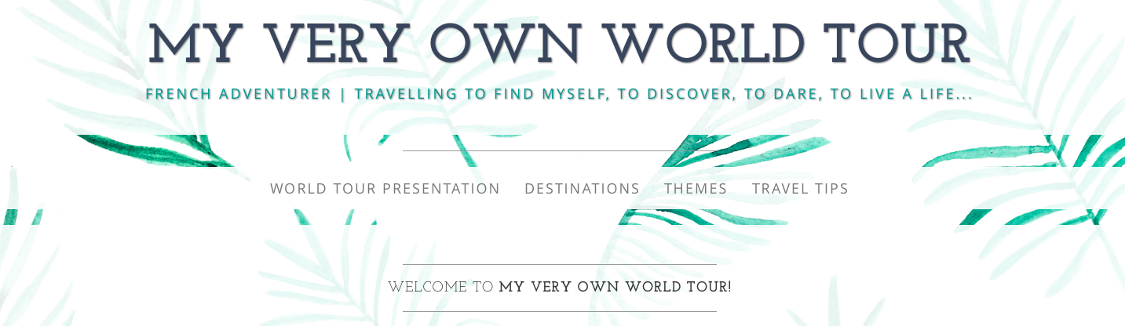

By Deborah BOMPANE B00497716

By Deborah BOMPANE B00497716

By Deborah BOMPANE –B00497716

WEBDESIGN PROJECT 2015

WEBDESIGN PROJECT 2015

by Deborah BOMPANE



TABLE OF CONTENTS

I. CONCEPTION 3

II. INITIATION 3

III. ANALYSIS 3

IV. DESIGN 4

A. HOME 7

B. ABOUT 9

C. CONTACT 10

D. SUBSCRIBE 11

E. SEARCH 11

F. WORLD TOUR PRESENTATION 12

G. DESTINATIONS 13

H. THEMES 14

I. TRAVEL TIPS 15

V. CONSTRUCTION 16

VI. TESTING 17

VII. MAINTENANCE 17

VIII. TECHNICAL REQUIREMENTS 17

# CONCEPTION

This web design project is about a website offering visitors the possibility to read about my future world tour. It aims to present myself, the world tour program, the different posts about specific locations and finally some useful travel tips.

Indeed, it may be hard to communicate with people while travelling around the world: emails or Facebook posts do not necessarily do the job as they are not used by everybody and do not regroup every piece of information at the same place in a convenient way.

Therefore quite often travellers do use websites to centralize all of the information. After assessing some of them in order to clearly identify potential problems visitors could encounter, I was able to understand that their main problem is the lack of clarity. Indeed, they often provide a lot of information not necessarily well organized and do contain tons of ads preventing the visitors from an optimal visit.

My goal here was to create an easy-to-visit website offering key information in a minimalist yet convenient and “beautiful” way.

My first audience would firstly be my family and close relatives as they would be the ones willing to follow my journey as they know me. It occurred to me that the future information provided might be looked up by unknown visitors which is why I have finally designed this website for a larger audience interested by travels in general.

# INITIATION

My goal is to provide clear up-to-date information about my world tour: to do so my main objectives are to deliver specific information in different sections in a logical way so the visitor is not lost and to make sure the clarity is optimal so he/she may want to stay longer.

My success criteria is to make sure my visitors understand quickly in which step of my world tour I am, that they can “live” my experience through the distance and finally that they may contact me easily.

# ANALYSIS

As previously stated, I aim to reach mainly two targets : my close relatives enquiring for where I am and what I am experiencing, and unknown visitors looking for specific information about world tours as an example.

My users like to be able to see where I am and what I am doing so they may be looking for maps, pictures, texts and videos.

As a world tour-related website clearly implies a lot of posts for each step of the tour, the user may expect tons of information but does not want to get lost because of it or he/she quickly will leave the website. This is why he/she is concerned with key information, sections easy to understand and maybe some interactivity so it is not about long portions of texts.

My site/app might be used in various contexts as more and more people use their smartphones to check up sites during the day. Whether it is consulted from a computer or a phone, it should remain practical without a lot of information to deal with at the same time.

Finally, there are some objective researches which state that “46% of mobile users report having difficulty interacting with a web page, and 44% complain that navigation was difficult.”[1], that “more than 9 out of 10 respondents (95%) agreed with the statement that "good user experience just makes sense."[2], and finally that “68% of users give up because they think you don't care about them”[3]. All of these stats give credit for my willingness to provide a clear website with different pages avoiding to have too much information on a same page.

# DESIGN

Regarding the design, I chose to include a navigation bar with practicable information at the top (Home, About, Social Media Links, Contact, Subscribe and Search) and another navigation bar with travel-related information (World Tour Presentation, Destinations, Themes and Travel Tips) below the jumbotron section so it could be easily accessible to the visitor.

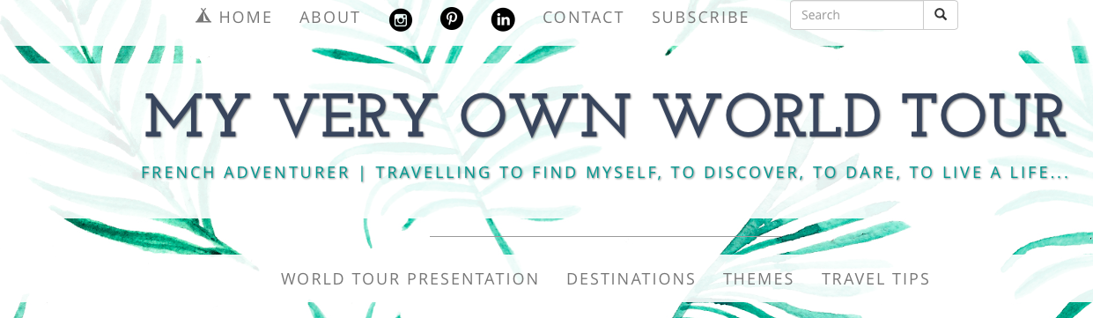

It is important to know that several designs were tried as to come to this final result ; the order of the different items on the top navigation bar was changed several times, the content of the address-bar below the main title also evolved, the footer also has seen numerous modifications.

The font-family was not changed but the colours (other than grey) evolved from slight green to darker green for the title as an example.

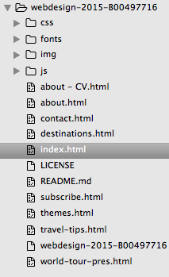

A balance had to be found as a potential important volume of information should be displayed.

The main information about the world tour can be found under the page world-tour-pres.htlm, the different travel posts under the page destinations.html, the travel posts linked to a theme under the page themes.html and the travel tips under the page travel-tips.html.

The footer simply includes a copyright mention and the possibility to go back to the top of the page which is especially useful for pages containing a lot of posts.

Regarding the content strategy on mobile, I plan on providing the same content as the site’s but the different pages on the two navigation bars will be condensed via a scrolling menu.

The design should remain minimalist with some touches of colours to evoke happiness and life.

The background follows this principle as it is mainly white with drawings of exotic leaves which remind of nature. The white is a source of light allowing the visitor to focus on text, videos and pictures. The leaves are a subtle element bringing a feeling of wellness and vacation.

The colours used for texts either are grey or a slight green to avoid the serious and tough feeling brought by the colour black.

Please find below an inspirational colour board:

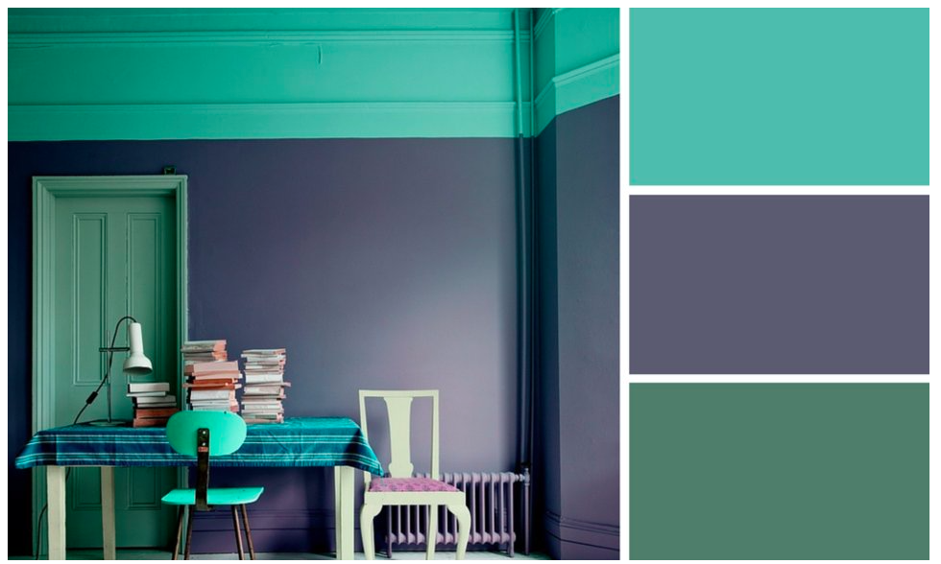

The green has been chosen as the main colour after white as it recalls of nature and of a wellbeing sensation.

The different fonts which are used are mainly timeless styles such as Helvetica Neue. They allow a good clarity and are a little bit curved giving a sensation of modernity.

The different icons have been chosen because of their minimalist style. The social media icons are in black so they are more obvious than the “illustrating ones” (such as the tent, convivial symbol of the Homepage and so forth).



The goal regarding style is to provide a clarity sensation through the predominance of white and to make the visitor feel at ease with slight touches of colours.

Please notice that the site has been built in order to remain responsive as much as possible (a specific work has been done on pictures and videos).

You may find below the description of each page.

## HOME

The Homepage’s role is to welcome the visitor; therefore I chose not to display any travel-related post there, as I did not want the visitor to get lost. A welcome message providing information about the site is the main first element the visitor can see. By scrolling down the page, he/she can then see where I am on a world map as it is key information I wanted to provide.

Finally, additional elements such as Instagram and Spotify modules are displayed. Instagram provides additional pictures which may not have been put on the site but might interest the visitor.

Spotify is optional here but brings another element which I found interesting as it can incite the visitor to stay longer and to feel like he/she is doing a road trip.

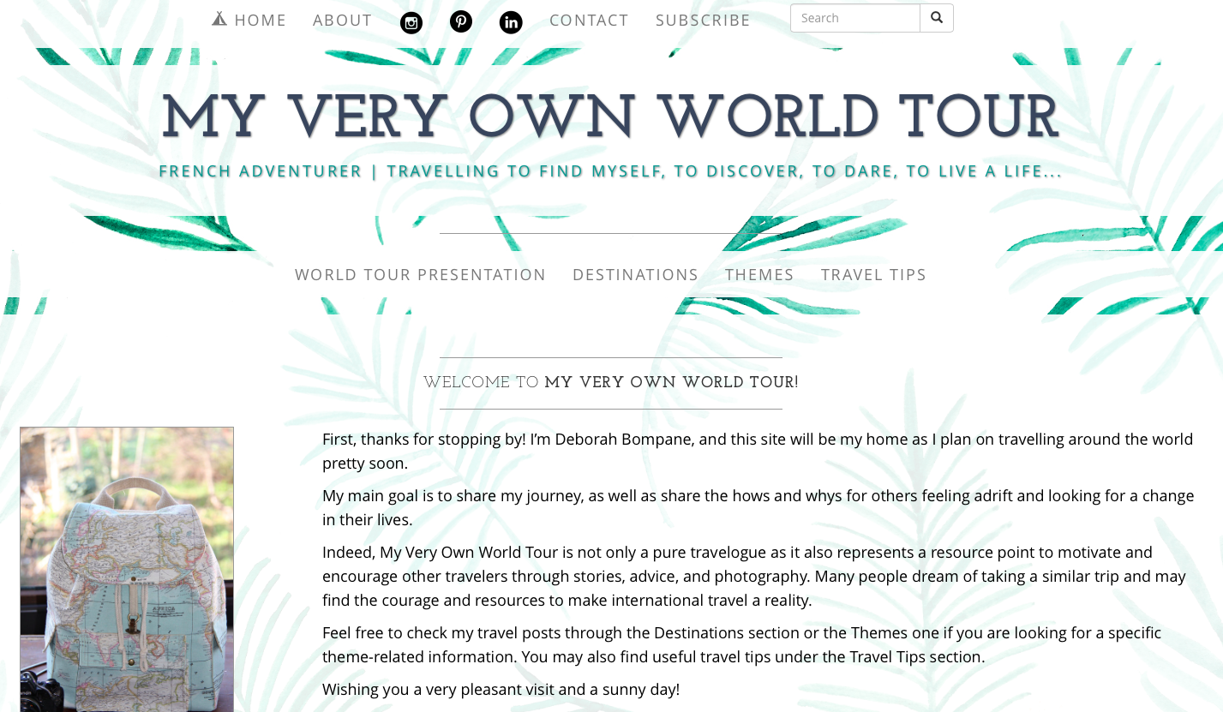

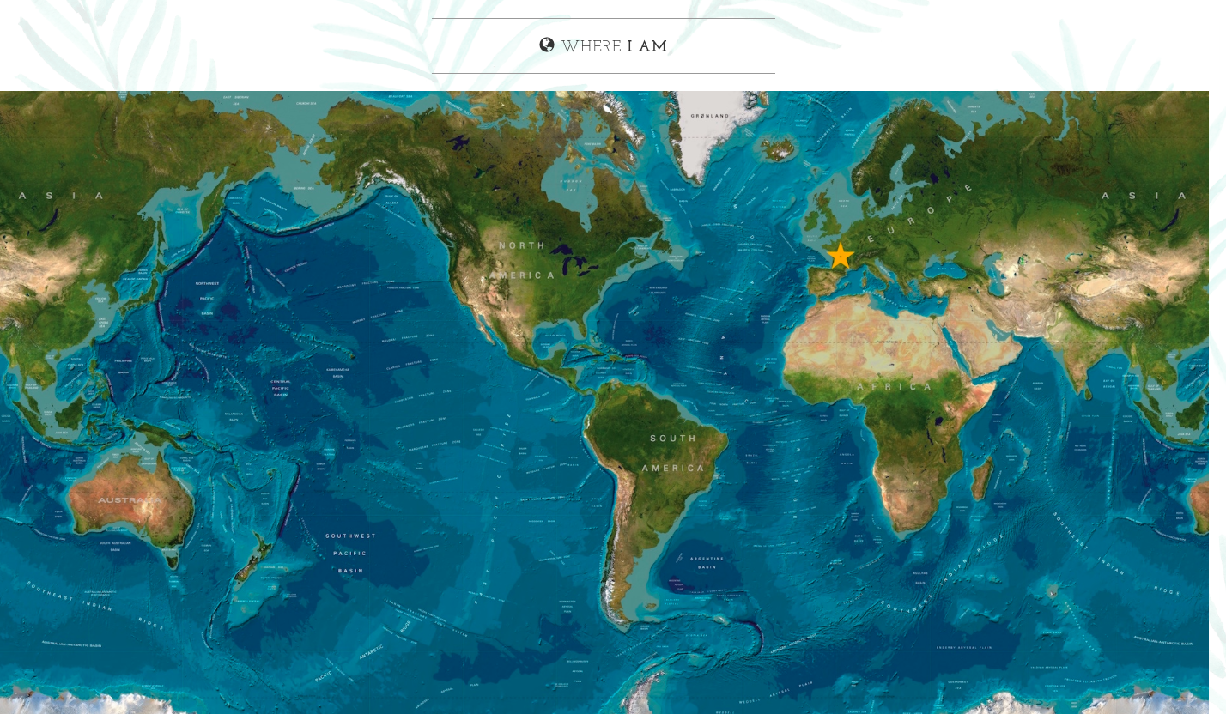

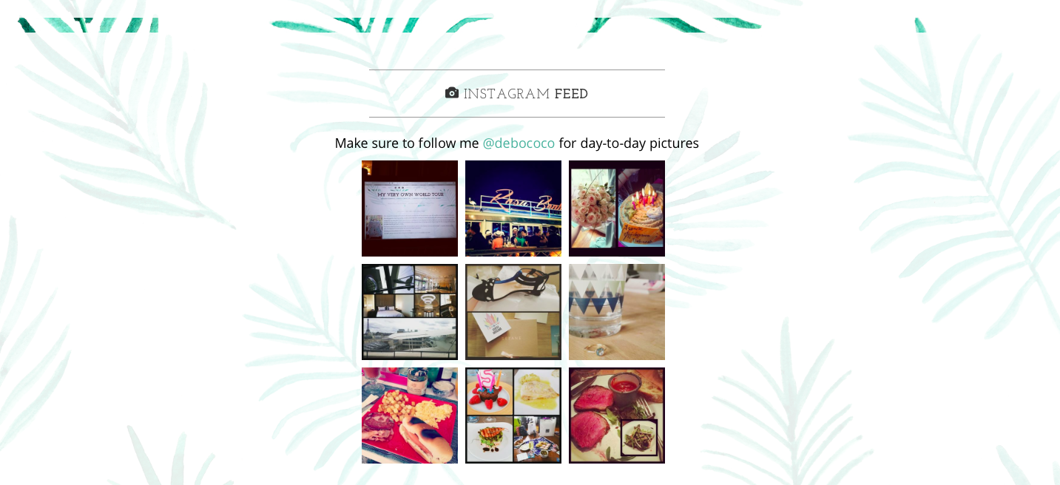

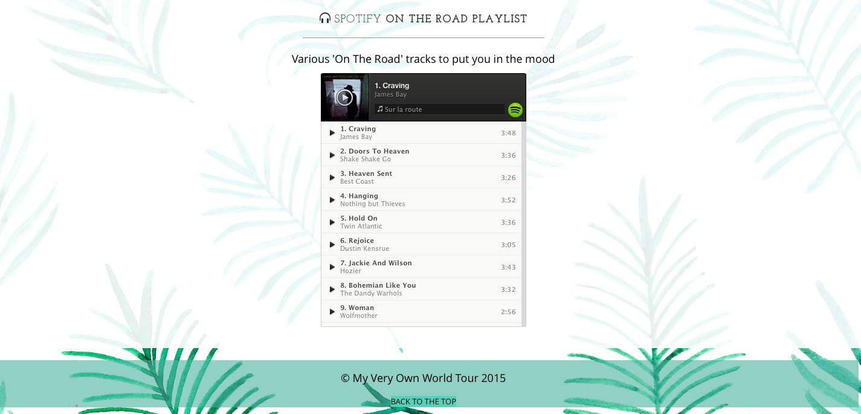

## ABOUT

The About page provides basic information about myself which might be useless for my close relatives but interesting for unknown visitors. A link to my resume is accessible from this page so visitors understand better my background or so potential recruiters might discover my profile.

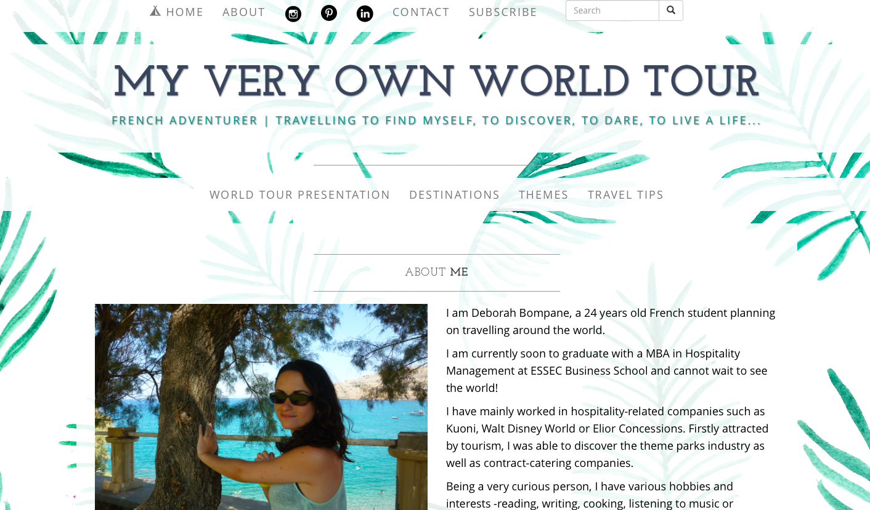

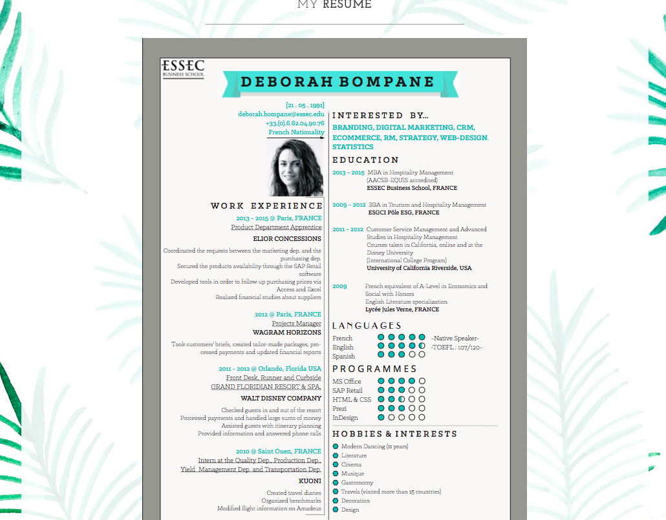

## CONTACT

The Contact page allows the visitor to see where I am based at, thanks to a Google Map, and to contact me through a contact form.

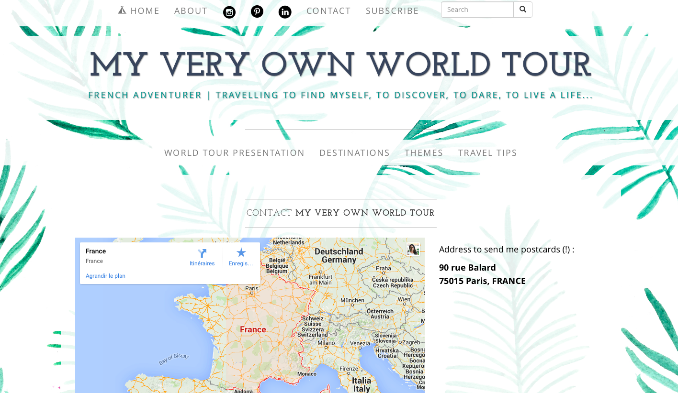

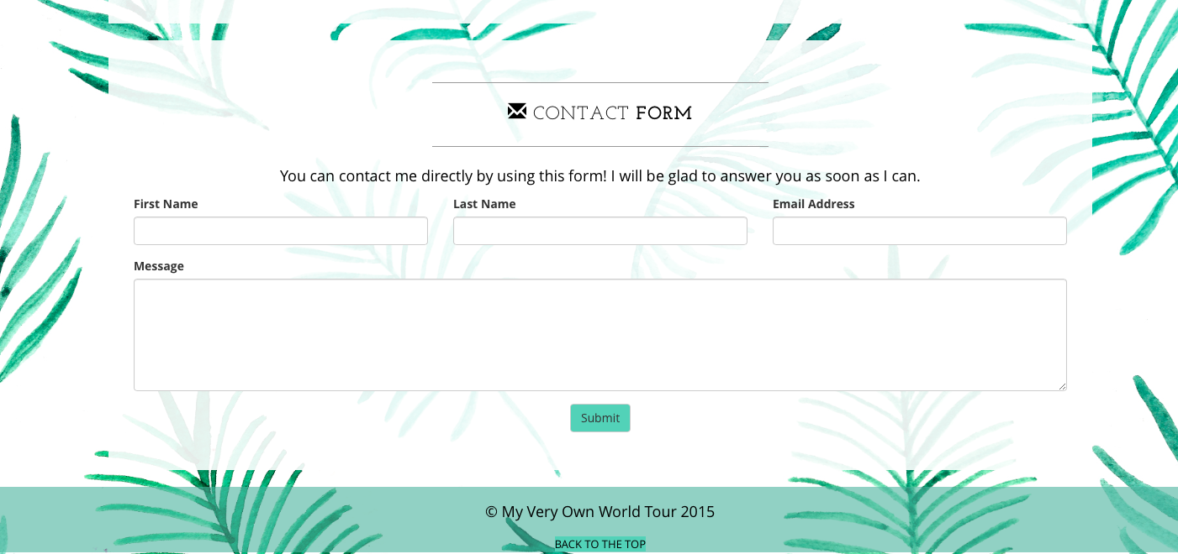

## SUBSCRIBE

As repeating visitors might be interested to know when a new post has been posted, they can easily subscribe to updates thanks to a subscription form.

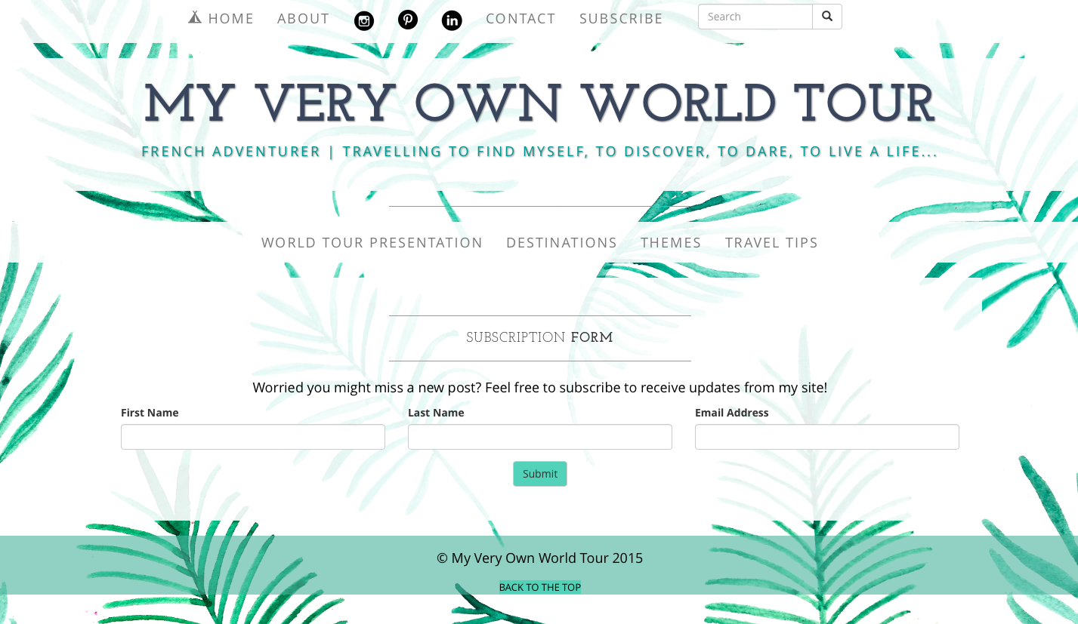

## SEARCH

A search box has been created in the navigation bar so the visitor can easily search for a specific content such as destinations or address.



## WORLD TOUR PRESENTATION

This page will later on display the word tour program, meaning the different planned steps. Dates, locations and further information will be posted so visitors have a clear idea of my tour.

A map representing the tour will also be displayed so they can have a visual representation.

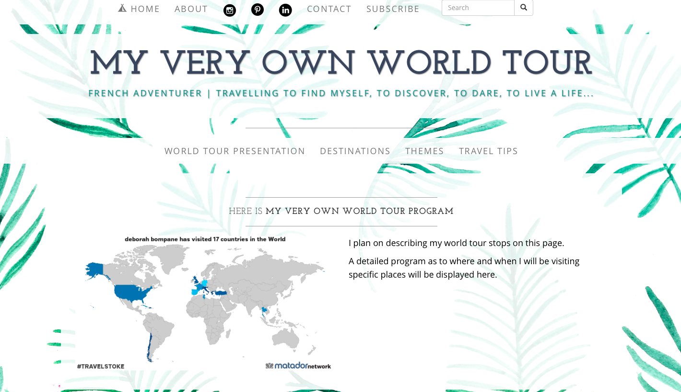

## DESTINATIONS

This page aims to display all of the travel-related posts. The videos and pictures have a lot space dedicated so they can be well seen by the visitors.

A panel containing a selector with a button aiming to filter the page is at the disposition of the visitor who can select posts linked to a specific destination.

Each post contains a title, a date and a quick description. The read more buttons will allow the article to appear after the description on the same page.

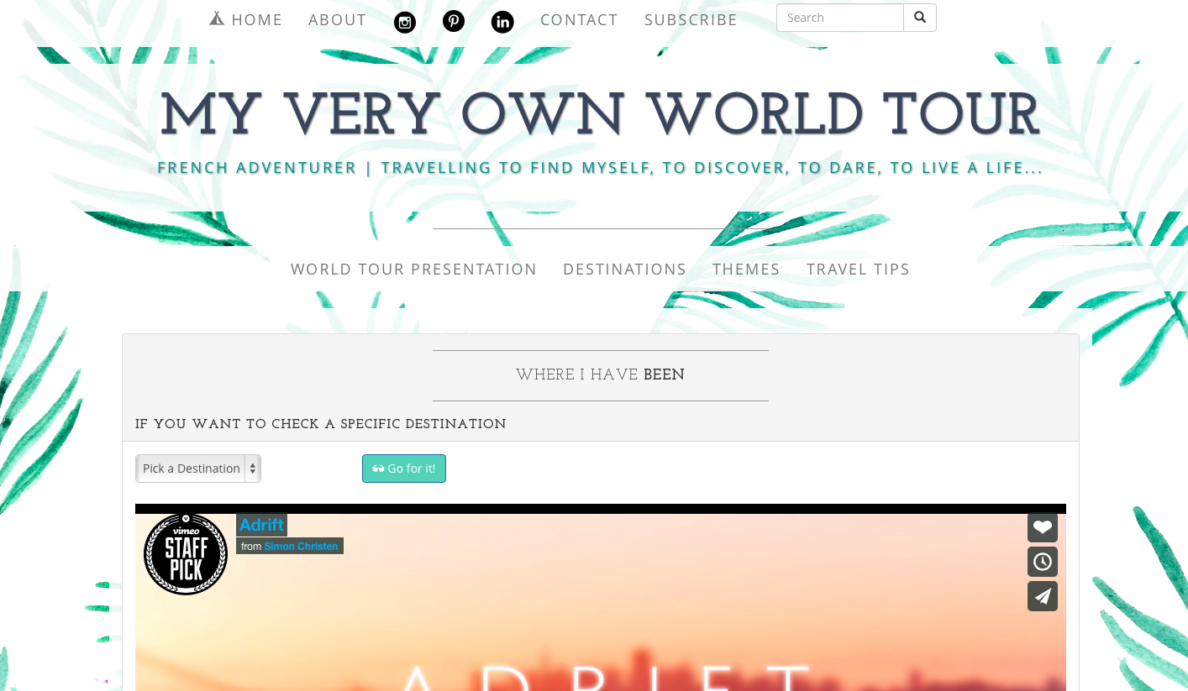

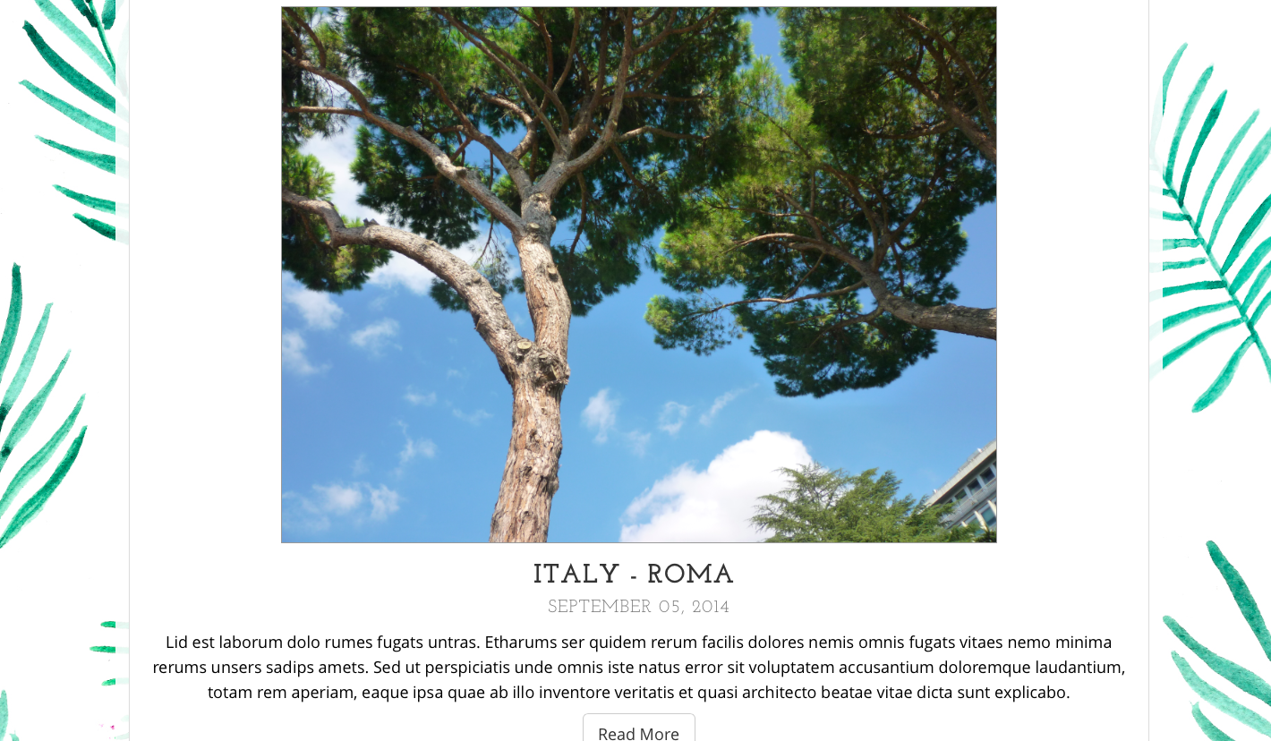

## THEMES

The Themes page basically is a duplication of the Descriptions page but contains posts linked to a specific activity. The selector allows choosing between the five senses (eat, smell, see, listen and touch) representing activities I might have experiences through my world tour. The evocation of the different senses has been made as to remind the visitor that a travel is a full experience requiring travellers to use all of their senses.

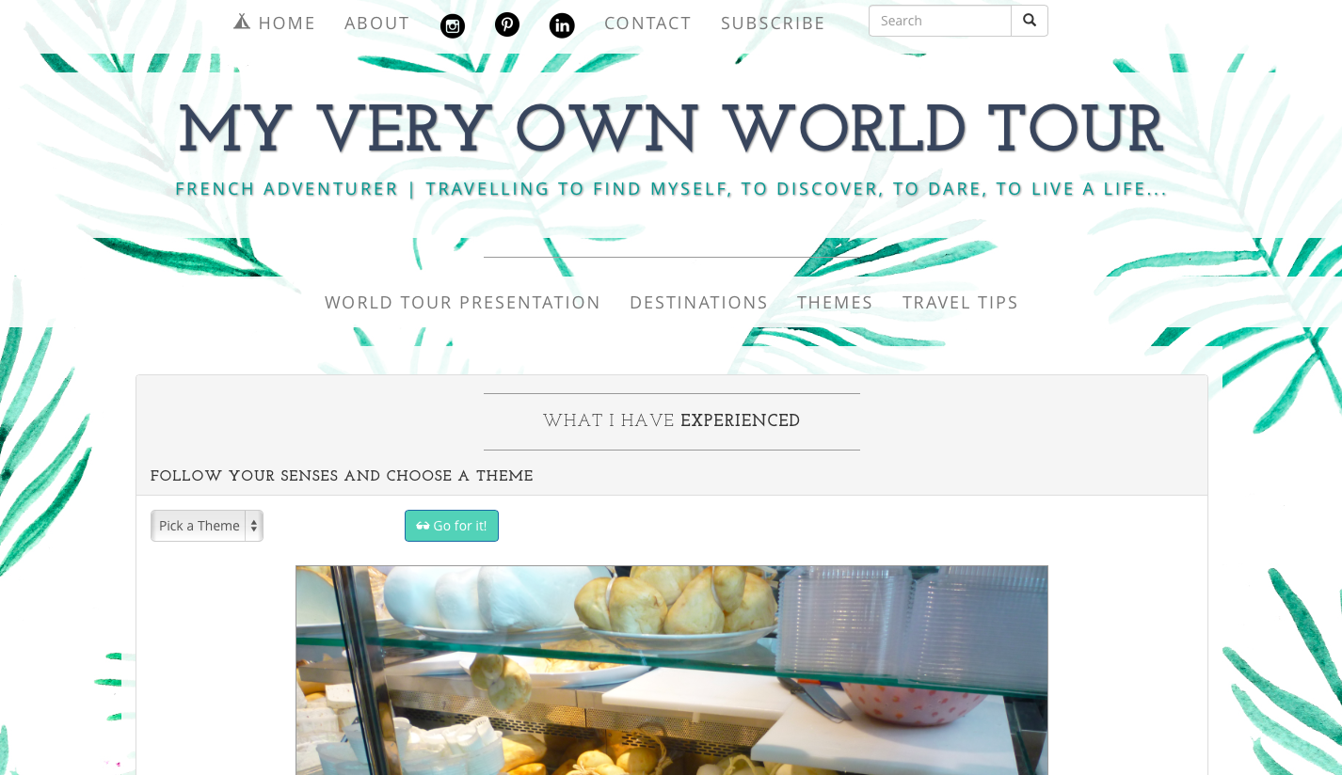

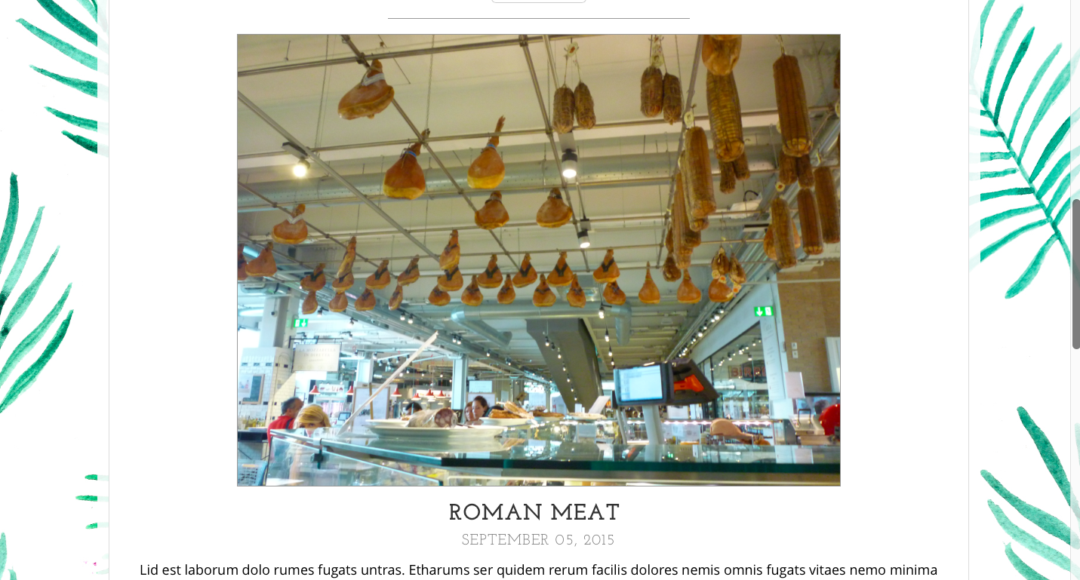

## TRAVEL TIPS

The Travel Tips page also displays posts but it focuses on travel tips encountered during my world tour which might interest visitors. The tips can also be filtered by category (packing, saving money, having the good attitude, taking pictures, staying organized).

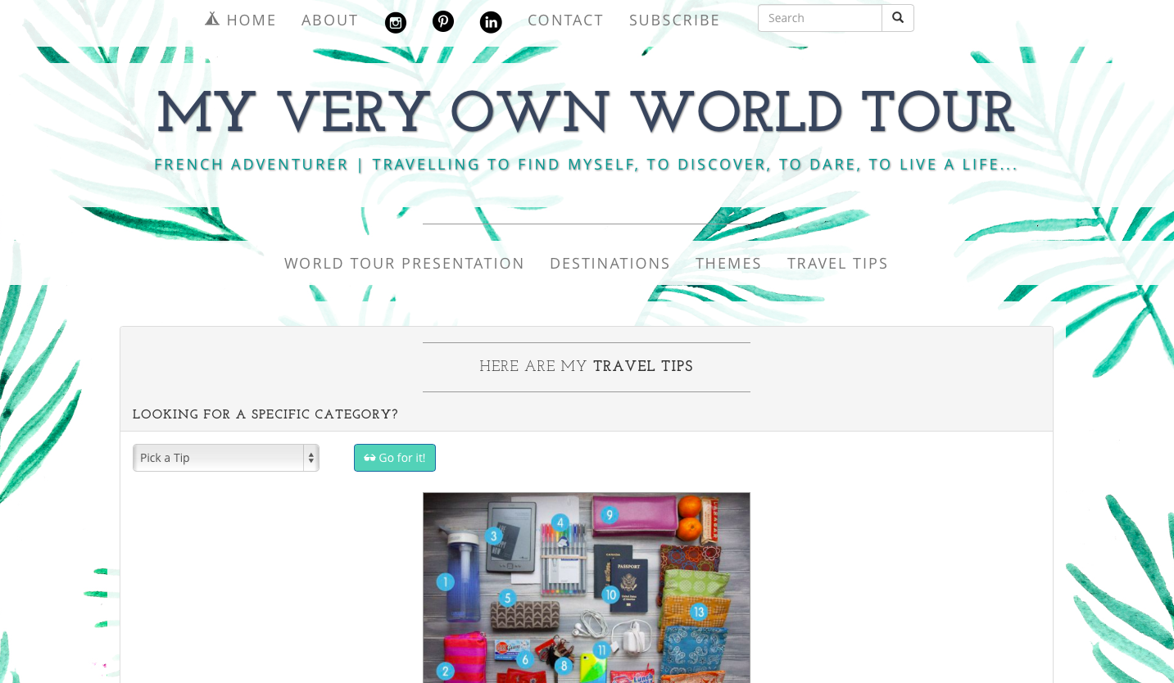

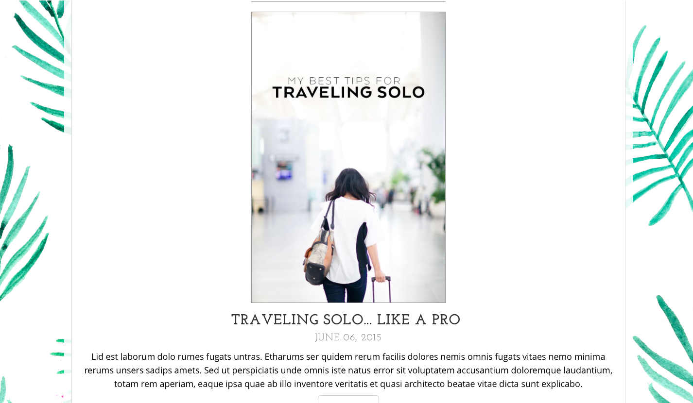

# CONSTRUCTION

The following template has been chosen on bootstrap.com:

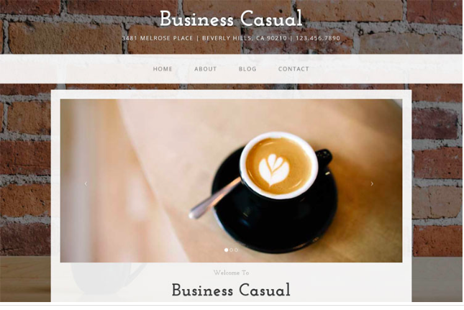

This example is a full website template for Bootstrap 3. It features four different HTML pages and a number of custom style components.

Its minimalist style appealed me and after assessing it I was able to come up with this final result:

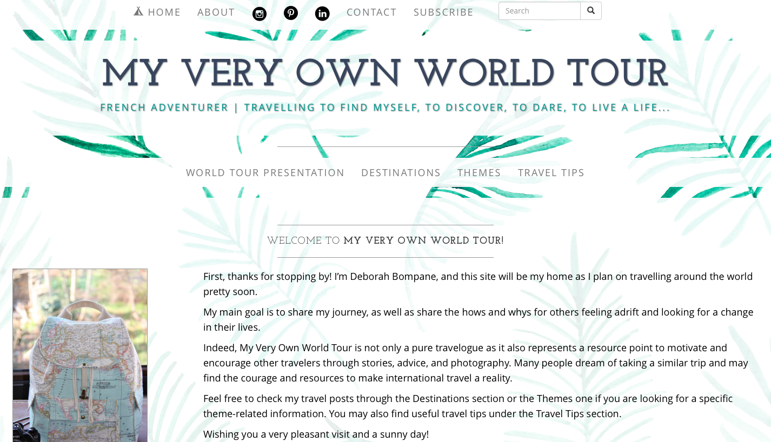

I had to add pages, sections such as navigation bars, icons, pictures, videos, maps, pdf, links and to remove elements such as the carousel which was not interesting to me. The CSS was helpful as it already integrated some responsive elements and the JavaScript present on the navigation bars allowed some minimal yet nice animation.

# TESTING

The testing part was primordial in a sense that I had to re-test at each modification to make sure it was properly working.

Other users have tested it so I could make sure whether or not its optimization was optimal so I had to redesign some pages to make it more simple.

# MAINTENANCE

There will be maintenance on the site :

-Homepage : the world map will have to be updated for each new location and the Spotify playlist might change after a while

-World-Tour Presentation page : the text will be updated when the world-tour will be defined as well as the map

-Destinations/Themes/Travel Tips pages : they will be updated for each new post

# TECHNICAL REQUIREMENTS

• present several pages linked together : home / resume / contact / map DONE

• create a main navigation menu DONE

• the main navigation menu should be optimized for its context DONE

• embed at least one image DONE

• embed at least one image gallery NOT DONE because unnecessary (would go against my light-content vision)

• embed at least one YouTube video DONE (Vimeo video)

• embed a contact form (name/mail/object/message) DONE

• embed a Google map DONE

• contact details should be available from anywhere DONE

• use at least 2 web fonts with proper pairing DONE

• (some of) your social networks should be available from anywhere DONE

• social network buttons should ideally display relative icon and colour DONE

• website should leave within a single repository (with proper subfolders). DONE

• your site should be traceable using Google Analytics NOT DONE as no domain name ?

• your site will have to display well in a 320px screen and larger DONE

• your site should use HTML5 elements as much as possible DONE ?

• your site should be optimized for robots NOT DONE

• your site should leverage on Open Graph Protocol DONE

• Accessible to your site should be optimized for people with visual impairment DONE

• your CSS will have to include at least two media queries DONE

1. http://www.keynote.com/docs/reports/Keynote_MSQ_Survey_2014_Full_Report.pdf
2. https://econsultancy.com/reports/user-experience-survey-report
3. https://vitamintalent.com/ux-statistic/#Tests